**Noah Smith**

**9/20/19**

**Assignment 7: A review of chapters 1 to 5**

**CIS 310 FALL 2019**

**Please do your best to answer the following six questions, using Visio or Lucid Chart.**

**1. Typically, a patient staying in a hospital receives medications that have been ordered by a particular doctor. Because the patient often receives several medications per day, there is a 1:M relationship between PATIENT and ORDER. Similarly, each order can include several medications, creating a 1:M relationship between ORDER and MEDICATION.**

1. **Identify the business rules for PATIENT, ORDER, and MEDICATION.**

* Patient: A patient can have many medical orders written for them. Each medical order is for a specific patient.
* Order: Each order can prescribe many medications and each medication can be prescribed in many orders.
* Medication: Each medication can be prescribed in many orders and each order can prescribe many medications.

**b. Create a Crow's Foot ERD that depicts a relational database model to capture these business rules.**

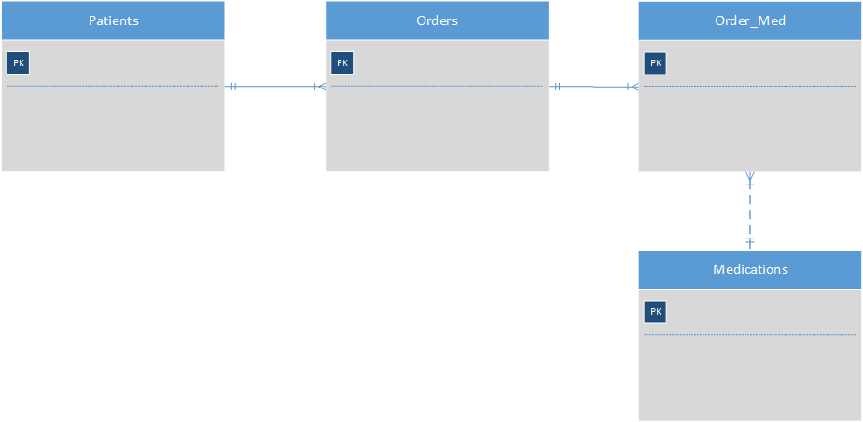

**2. United Broke Artists (UBA) is a broker for not-so-famous painters. UBA maintains a small network database to track painters, paintings, and galleries. A painting is painted by a particular artist, and that painting is exhibited in a particular gallery. A gallery can exhibit many paintings, but each painting can be exhibited in only one gallery. Similarly, a painting is painted by a single painter, but each painter can paint many paintings. Using PAINTER, PAINTING, and GALLERY, in terms of a relational database:**

1. **What tables would you create, and what would the table components be? Identify each table with attributes**

* Three Tables would be created with the following attributes:
  + Painter: PainterNumber, PainterLastName, PainnterFirstName.
  + Gallery: GalleryNumber, GalleryName.
  + Painting: PaintingNumber, PaintingTitle, PainterNumber, GalleryNumber.

1. **Identify applicable business rules for each entities (tables)**

* A painter can paint many paintings.
* Each painting is painted by one painter.
* A gallery can exhibit many paintings.
* A painter can have paintings at more that one gallery at a time.

1. **Show the relationships in a Crow’s Foot diagram**

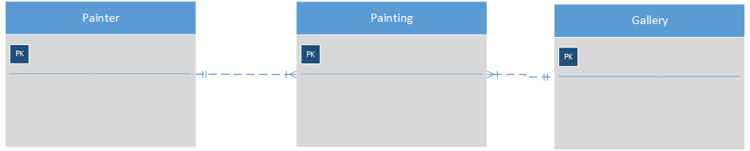

**3. Using the ERD you created from Problem 2, create the relational schema. (Create an appropriate collection of attributes for each of the entities. Make sure you use the appropriate naming conventions to name the attributes.)**

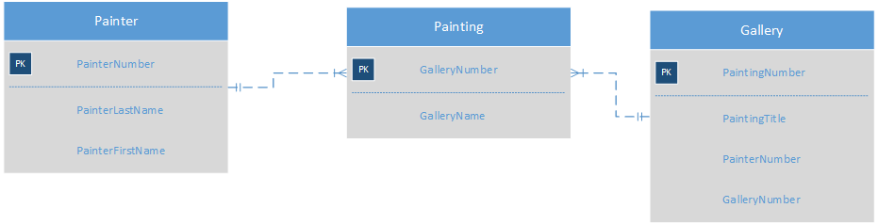

**4. Convert the ERD from Problem 1 into the corresponding UML class diagram.**

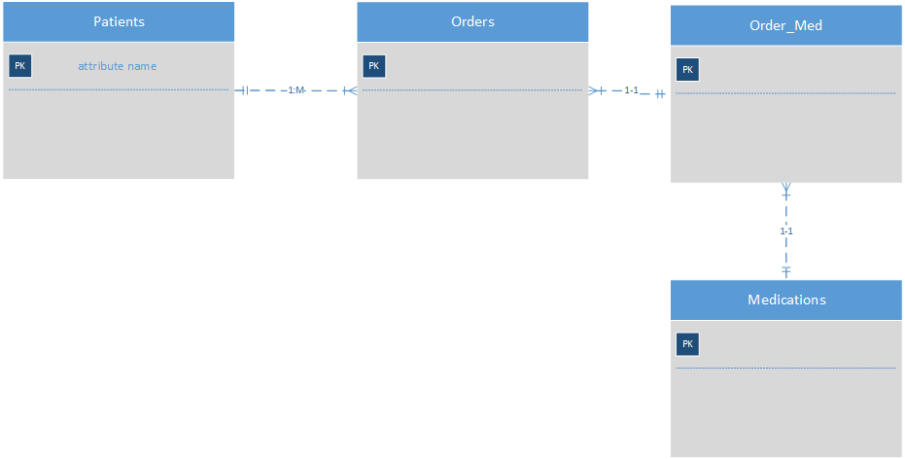

**5. Identify the business rules from the depicted relationships in the Crow’s Foot ERD shown in Figure 5.1**

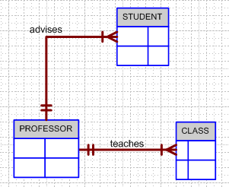

**Figure 5.1 The Crow’s Foot ERD for Problem 5**

* A profession can teah many classes.
* Each class is tought by one professor.
* A professor can advise many students.
* A student is advised by one professor.

**6. Create a Crow’s Foot ERD to include the following business rules for the ProdCo company:**

1. **Each sales representative writes many invoices.**
2. **Each invoice is written by one sales representative.**
3. **Each sales representative is assigned to one department.**
4. **Each department has many sales representatives.**
5. **Each customer can generate many invoices.**
6. **Each invoice is generated by one customer.**

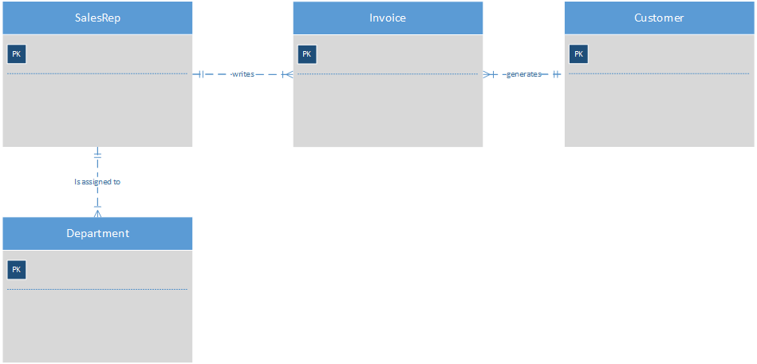

**7. What is normalization and why it’s important?**

**a. describe the three forms**

* First Normal Form:
  + Should only have single valued attibutes.
  + Values stored in a column should be of the same domain.
  + All the columns in the table should have unique names.
  + The order in which data is stored does not matter.
* Second Normal Form:
  + Should be in the first normal form.
  + Should not have partial dependency.
* Third Normal Form:
  + Should be in the second normal form.
  + For each functional dependency, X should be a super key.

1. **describe data modeling checklist**

The data model checklist is used to help a designer design a database correctly. What is the functionality that is required? What are the use cases related to this data?